**Practical 9:**

**Objective**: Finding Eigenvalues and Eigenvectors

**Part A:** Use MATLAB to determine the eigenvalues and eigenvectors for the following system

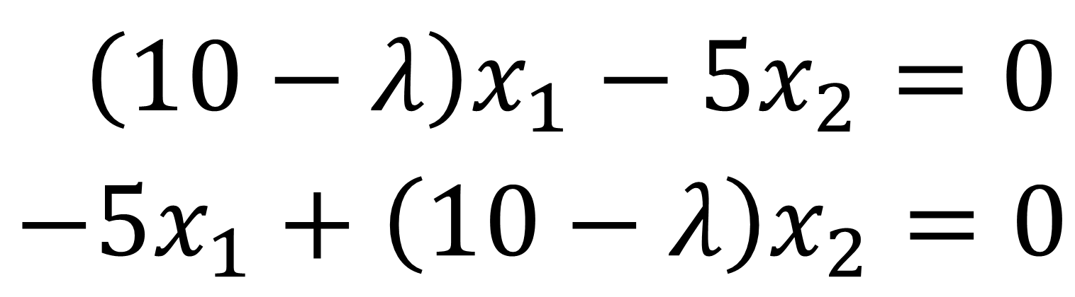

**octave:1>** A = [10 -5; -5 10]

A =

10 -5

-5 10

**octave:2>** e = eig(A)

e =

5

15

**octave:3>** [v, lamda] = eig(A)

v =

-0.70711 -0.70711

-0.70711 0.70711

lamda =

Diagonal Matrix

5 0

0 15

$$\left[\begin{matrix}0.8 & 0.3 \\ 0.2 & 0.7\end{matrix}\right]\left[\begin{aligned}x_{1} \\ x_{2}\end{aligned}\right]=\left[\begin{aligned}0 \\ 0\end{aligned}\right]$$

**octave:4>** A = [0.8 0.3; 0.2 0.7]

A =

0.80000 0.30000

0.20000 0.70000

**octave:5>** e = eig(A)

e =

1.00000

0.50000

**octave:6>** [v, lamda] = eig(A)

v =

0.83205 -0.70711

0.55470 0.70711

lamda =

Diagonal Matrix

1.00000 0

0 0.50000

**Part B:**

1. Use MATLAB to determine all the eigenvalues and eigenvectors for the following system

$$x_{1}-x_{2}=0$$

${-x}_{1}+2x_{2}-x_{3}=0$

$${-x}_{2}+x_{3}=0$$

**octave:7>** A = [1 -1 0; -1 2 -1; 0 -1 1]

A =

1 -1 0

-1 2 -1

0 -1 1

**octave:8>** e = eig(A)

e =

3.9251e-17

1.0000e+00

3.0000e+00

**octave:9>** [v, lamda] = eig(A)

v =

-5.7735e-01 -7.0711e-01 4.0825e-01

-5.7735e-01 9.7145e-17 -8.1650e-01

-5.7735e-01 7.0711e-01 4.0825e-01

lamda =

Diagonal Matrix

9.9966e-17 0 0

0 1.0000e+00 0

0 0 3.0000e+00

1. What is the dominant eigenvalue of the above system?

3.0e+00

1. Write the coefficient matrix with dominant eigenvalue in Part (ii).

**octave:10>** lamda = 3

lamda = 3

**octave:11>** [1-lamda -1 0; -1 2-lamda -1; 0 -1 1-lamda]

ans =

-2 -1 0

-1 -1 -1

0 -1 -2

1. Perform row operations to obtain rref of the matrix in Part (iii).

**octave:12>** D = [1-lamda -1 0; -1 2-lamda -1; 0 -1 1-lamda]

D =

-2 -1 0

-1 -1 -1

0 -1 -2

**octave:13>** R = rref(D)

R =

1 0 -1

0 1 2

0 0 0

1. Use manual calculation to find the dominant eigenvector that associated with the dominant eigenvalue in Part (ii).
2. Use MATLAB to verify your answer in Part (v).

**octave:20>** vpower =[1; -2; 1]

vpower =

1

-2

1

**octave:21>** vMATLAB = vpower / norm(vpower)

vMATLAB =

0.40825

-0.81650

0.40825

**Part C: Rayleigh Quotient**

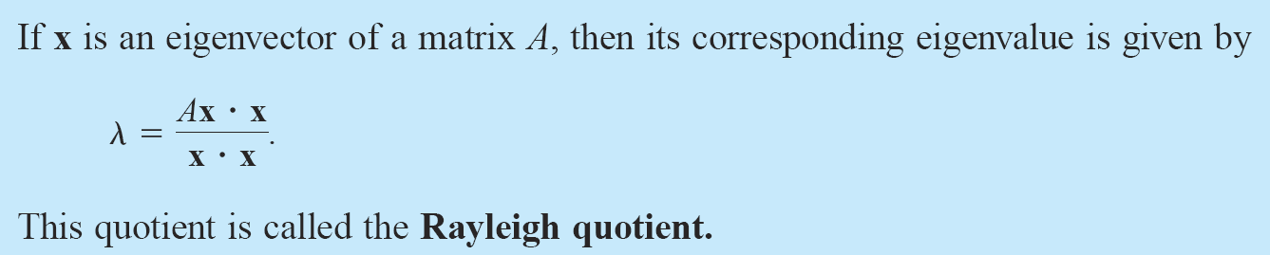

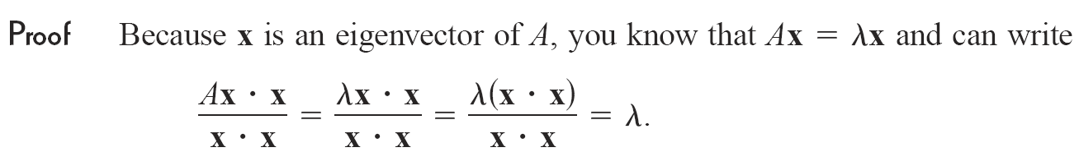

In cases for which the power method generates a good approximation of a dominant eigenvector, the Rayleigh quotient provides a correspondingly good approximation of the dominant eigenvalue.

1. Complete six iterations of the power method (using scaled approximation) to approximate a dominant eigenvector of

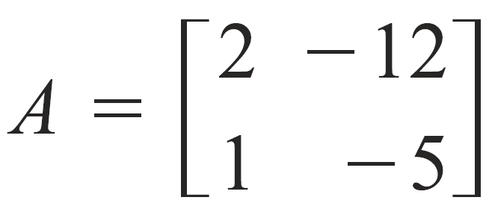

**octave:28>** A = [2 -12; 1 -5]

A =

2 -12

1 -5

**octave:29>** x0 = [1; 1]

x0 =

1

1

**octave:30>** X1 = A*X0

X1 =

-10

-4

**octave:31>** X2 = A*X1

X2 =

28

10

**octave:32>** X3 = A*X2

X3 =

-64

-22

**octave:33>** X4 = A*X3

X4 =

136

46

**octave:34>** X5 = A*X4

X5 =

-280

-94

**octave:35>** X6 = A*X5

X6 =

568

190

The approximated X = [2.98947; 1]

1. Use the above result to approximate the dominant eigenvalue of the matrix $A$.

**octave:4>** (A*X)'*X

ans = -20.010

**octave:5>** axx = (A*X)'*X

axx = -20.010

**octave:6>** xx = X'*X

xx = 9.9401

**octave:7>** lamda = axx / xx

lamda = -2.0130

**octave:40>** eig(A)

ans =

-1

-2

**Part D: The Power Method with Scaling**

The power method may generate vectors with large components. To avoid this problem, we can at each step multiply the vector $x=\left[\begin{aligned}x_{1} \\ x_{2} \\ ⋮ \\ x_{n}\end{aligned}\right]$ by $\frac{1}{max\left\{\left|x_{1}\right|,\left|x_{2}\right|,…,\left|x_{n}\right|\right\}}$

1. Calculate seven iterations of the power method with scaling to approximate a dominant eigenvector of the matrix

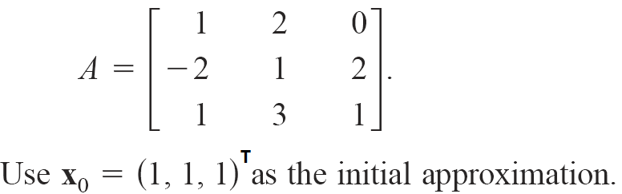

1. Use your answer in Part (i) to approximate the dominant eigenvalue.

**Part E: Programming Practice**

Write a program to perform operations in Part C. Your program should take the following inputs from the user:

1. Coefficient Matrix, $A$
2. Initial approximation, $X_{0}$
3. Iteration size, $n$